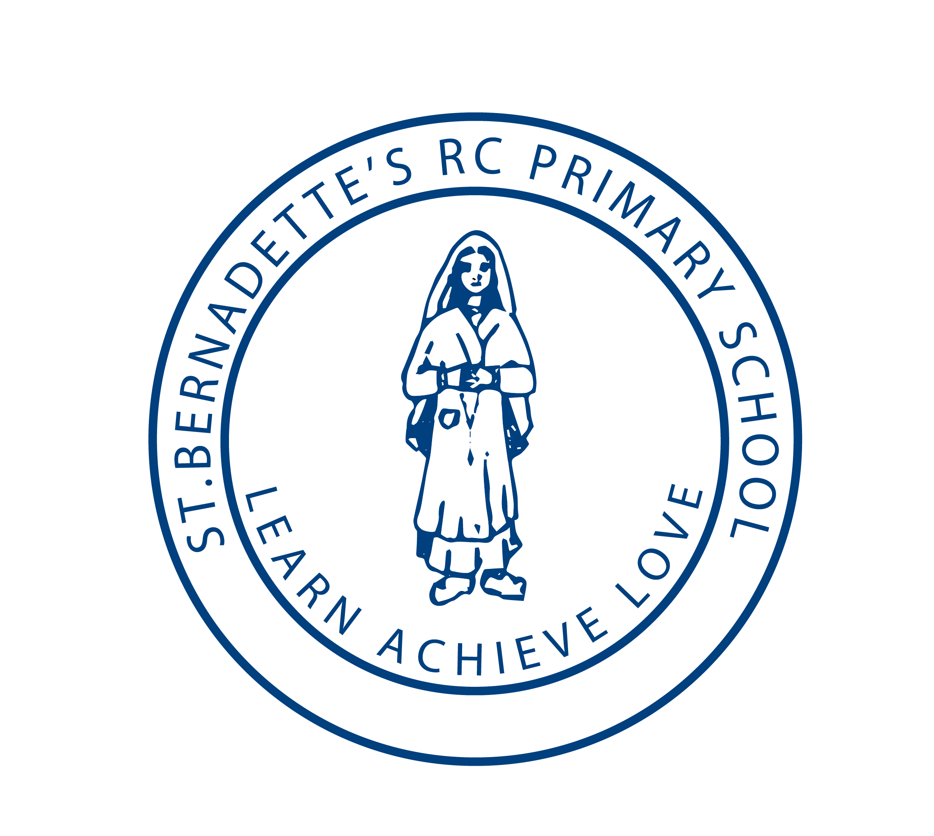
St Bernadette’s RCP Newsletter 
8th December 2017
Punctuality and Attendance
There have been 26 occasions of late arrivals this week. Please remember school doors open at 8:45 and close at 8:55

This week’s attendance
Buttons 97.94%
Smarties 97.10%
Year1 91.85%
Year 1/ 2 95.79%
Year 2 93.91%
Year 3 94.44%
Year 3/ 4 97.86%
Year 4 91.04%
Year 5 94.32%
Year 5/ 6 96.83%
Year 6 95.56%
Whole School 95.03%
Pope Francis’ Tweet of the Week!
No child of God can be discarded in His eyes.
He entrusts a mission to each one of us.

The love of Christ is like a “spiritual GPS” that guides us unerringly towards God and towards the heart of our neighbour.

Mince Pies & Merriment Morning
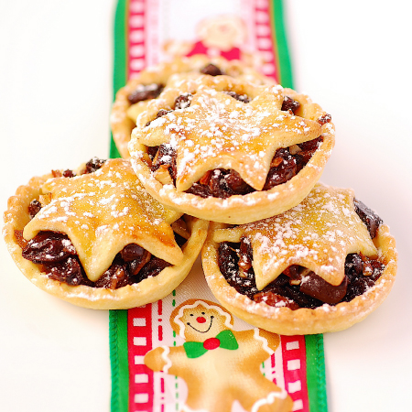
Thank you to everyone who came to help and support this morning. The children entertained us with songs from each class and there were hot drinks and Christmas treats aplenty. We even raised £440.50 for PTA funds thanks to your generous donations.

Christmas Fair
A massive thank you to everyone who has donated or helped put together last Friday’s Christmas fair. It was a fantastic night and opening to the festive season. We raised a massive £3,227.00 for PTA funds towards laptops and playground equipment.

Advent Assemblies
Please join us again at 9.00am on Monday morning in school for our next Advent Assembly. All welcome to join us.

School Christmas Dinner
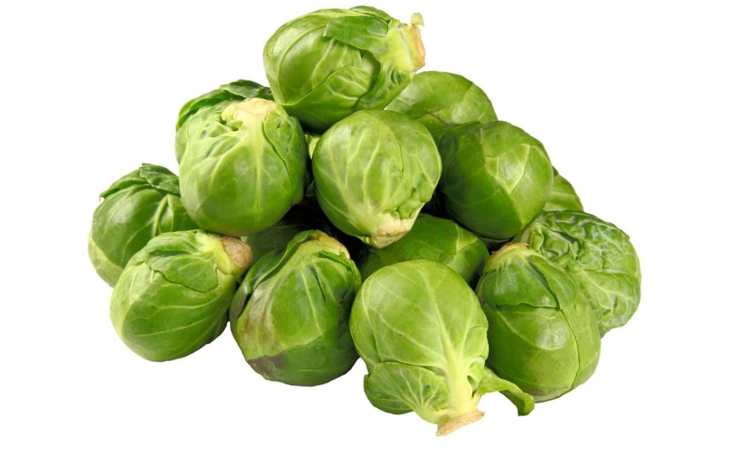
The children on school dinners will have their Christmas lunch on Wednesday 13th December. As usual the children on packed lunch will be sat with them, but we are unable to offer Christmas lunch to everyone this year. Children on packed lunches are welcome to bring a special treat lunch, and it will still be a very festive celebration together.

Panto Trip
A reminder that our trip is next Friday 15th December for the whole school. Children are expected back at school for approx. 4.00pm. We will send text alerts to update you of their progress and any delays due to traffic.

Crafty Christingle
Sunday, 17th December 2017, 4-6pm at St Bernadette's Parish Centre and church
Children and adults are invited to come along to have fun working together on a number of creative arts and crafts activities with an Advent focus (including making your own Christingle). Our Crafty Christingle craft-making activities will
start in St Bernadette’s Parish Centre at 4pm, followed by a service in St Bernadette’s Church, where children will be able to bring along their Christingles
and have their cribs blessed. We will round off our special celebration with refreshments in the Parish Centre. Please note that children need to be accompanied and supervised by an adult. If you and your family would like to participate in this very special celebration, please sign up on the booking sheets in both church porches.

Mini Vinnies Food Bank
Thank you, yet again for your very generous donations of foods and gifts for local families and people in need at Christmas.

Please note:
School closes at 1.30 on Thursday 21st December.
There is no after school facility on that day.

Diary Dates for Autumn Term
10.12.17 St. Bernadette’s Choir are singing at the Longfield Suite with Bury Music Service at 2pm.
12.12.17 Nursery Nativity at 9.45am in School Hall
12.12.17 Reception Nativity at 2pm.
13.12.17 St.Monica’s Advent Service 6.30pm in St. Bernadette’s Church. St. Bernadette’s
Choir are singing with St. Michael’s choir.

15.12.17 Whole School Christmas Pantomime at Bolton Macron Stadium
19.12.17 KS1 Christmas Production at 2pm and 6pm.
20.12.17 Whole School Christmas Concert 6.30pm in social centre.
21.12.17 Finish for Christmas at 1.30pm

